SET 9 – ONLINE LEARNING ACTIVITY ANALYSIS
Aim
To analyze online learning activity and student performance using histograms, boxplots, scatter plots, moving average line charts, and an interactive Tableau dashboard.

Dataset: Monthly Product Sales
Product ID | Product Name | January Sales | February Sales | March Sales
1 | Product A | 2000 | 2200 | 2400
2 | Product B | 1500 | 1800 | 1600
3 | Product C | 1200 | 1400 | 1100

PROGRAM 1: Histogram and Boxplot of Quiz Score
Import the Online_Learning_Activity dataset into R. Create a histogram of Quiz_Score and a boxplot of Quiz_Score by Course.
Procedure:
- Import the CSV dataset into R.
- Select the Quiz_Score column.
- Create a histogram to show the distribution of quiz scores.
- Create a boxplot to compare quiz scores for different courses.
- Add titles and axis labels.
- Observe the student performance.
# Import dataset
library(readxl)
data <- read.csv("Online_Learning_Activity.xlsx")

# Histogram of Quiz Score
hist(data$Quiz_Score,
main = "Distribution of Quiz Scores",
xlab = "Quiz Score",
ylab = "Number of Students")

# Boxplot of Quiz Score by Course
boxplot(Quiz_Score ~ Course,
data = data,
main = "Quiz Score by Course",
xlab = "Course",
ylab = "Quiz Score")

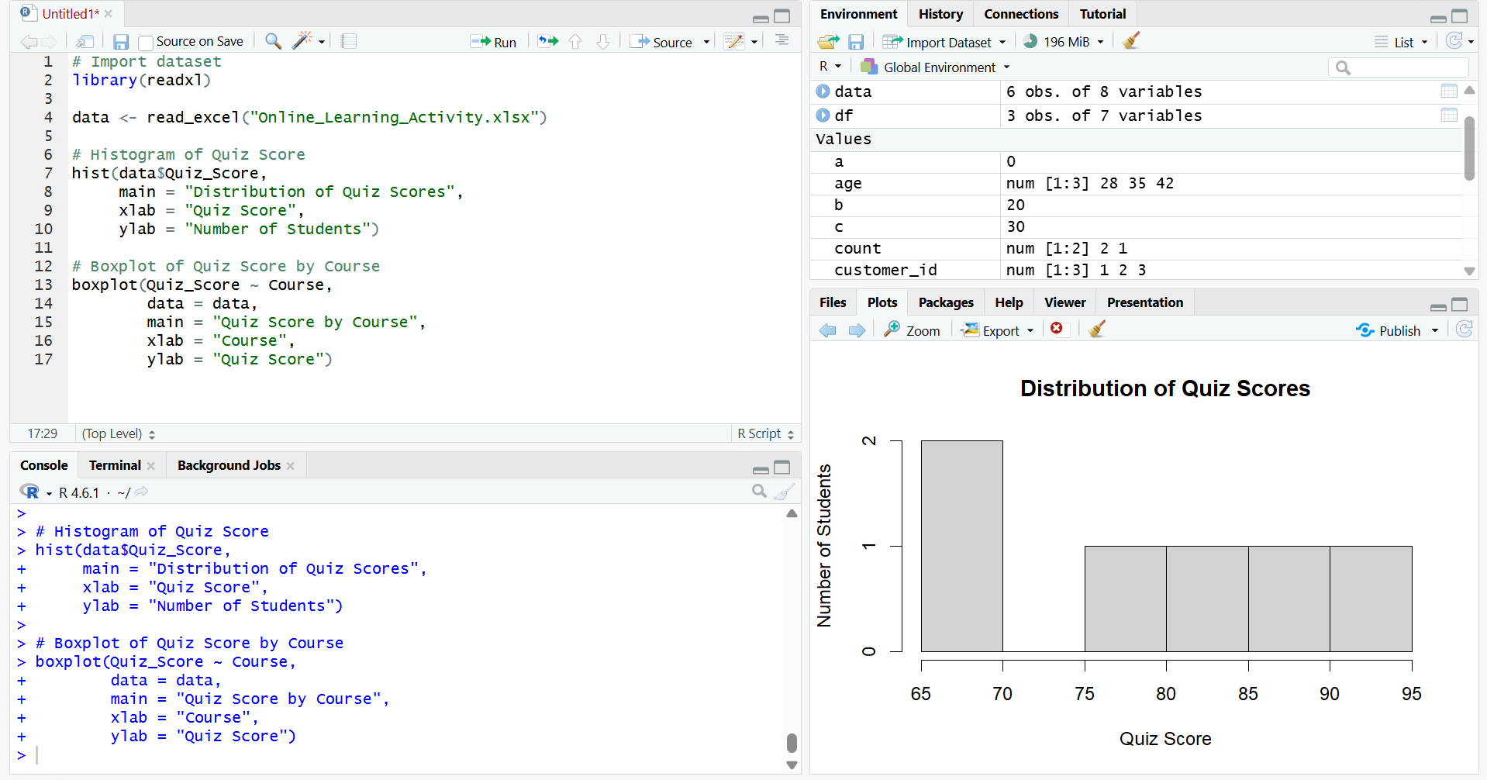

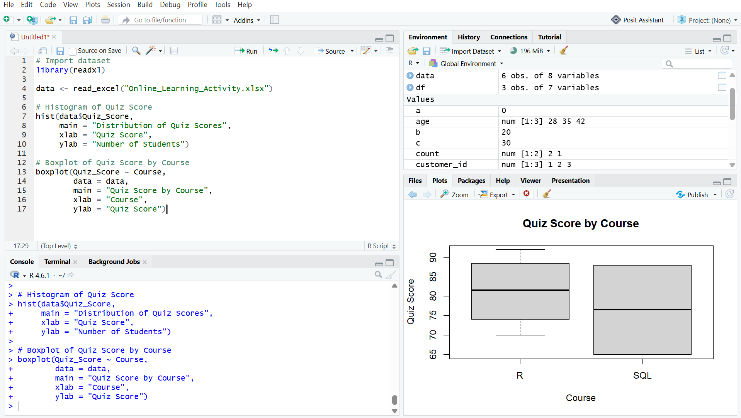
Output 1: Quiz Score Histogram and Boxplot
Observation
The histogram shows the distribution of quiz scores. The boxplot helps compare the performance of students in the R and SQL courses.

PROGRAM 2: Study Time vs Quiz Score Scatter Plot
Create a scatter plot between Study_Time and Quiz_Score. Represent Videos_Watched using bubble size and apply transparency.
Procedure:
- Select Study_Time and Quiz_Score.
- Create a scatter plot.
- Use Videos_Watched to control the bubble size.
- Apply transparency to the bubbles.
- Add title and axis labels.
- Observe the relationship between study time and quiz score.

# Load library
library(readxl)

# Import Excel file
data <- read_excel("Online_Learning_Activity.xlsx")

# Create scatter plot
plot(data$`Study_Time (hrs)`, data$Quiz_Score,
cex = data$Videos_Watched / 5,
pch = 19,
col = rgb(0, 0, 1, 0.5),
main = "Study Time vs Quiz Score",
xlab = "Study Time (hrs)",
ylab = "Quiz Score")
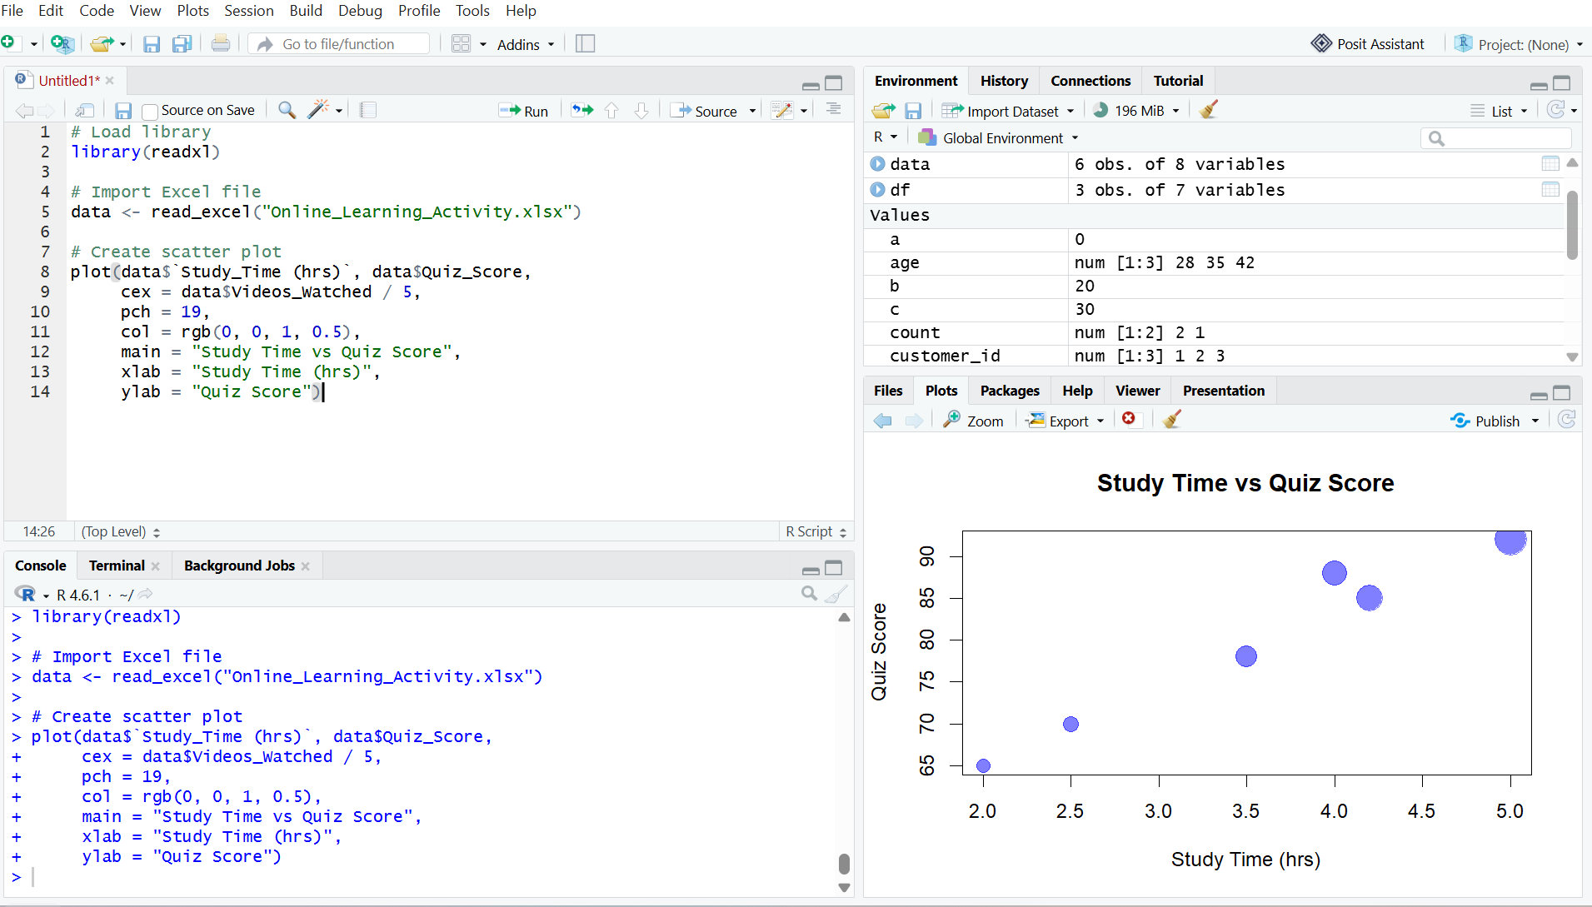
Output 2: Study Time vs Quiz Score Bubble Scatter Plot
Observation
The scatter plot shows that students who spend more time studying generally have higher quiz scores. Students who watched more videos are represented by larger bubbles.

PROGRAM 3: Monthly Average Quiz Score with Moving Average
Convert Login_Date into Date format, calculate the average quiz score per month, and create a line chart with moving average smoothing.
Procedure:
- Import the dataset into R.
- Convert Login_Date into Date format.
- Extract the month from the login date.
- Calculate the average quiz score for each month.
- Create a line chart.
- Calculate a moving average to smooth the trend.
- Add the moving average to the chart.
- Observe the monthly performance trend.
# Load library
library(readxl)

# Import Excel file
data <- read_excel("Online_Learning_Activity.xlsx")

# Convert Login_Date to Date format
data$Login_Date <- as.Date(data$Login_Date)

# Create month
data$Month <- format(data$Login_Date, "%Y-%m")

# Calculate average quiz score per month
monthly_avg <- aggregate(Quiz_Score ~ Month,
data = data,
FUN = mean)

# Print monthly average
print(monthly_avg)

# Calculate moving average
moving_avg <- c(
NA,
mean(monthly_avg$Quiz_Score[1:2]),
mean(monthly_avg$Quiz_Score[2:3])
)

# Create line chart
plot(1:nrow(monthly_avg),
monthly_avg$Quiz_Score,
type = "o",
main = "Monthly Average Quiz Score",
xlab = "Month",
ylab = "Average Quiz Score",
xaxt = "n")

# Add month names
axis(1,
at = 1:nrow(monthly_avg),
labels = monthly_avg$Month)

# Add moving average
lines(1:nrow(monthly_avg),
moving_avg,
type = "o",
lty = 2)

# Add legend
legend("bottomright",
legend = c("Average Score", "Moving Average"),
lty = c(1, 2))

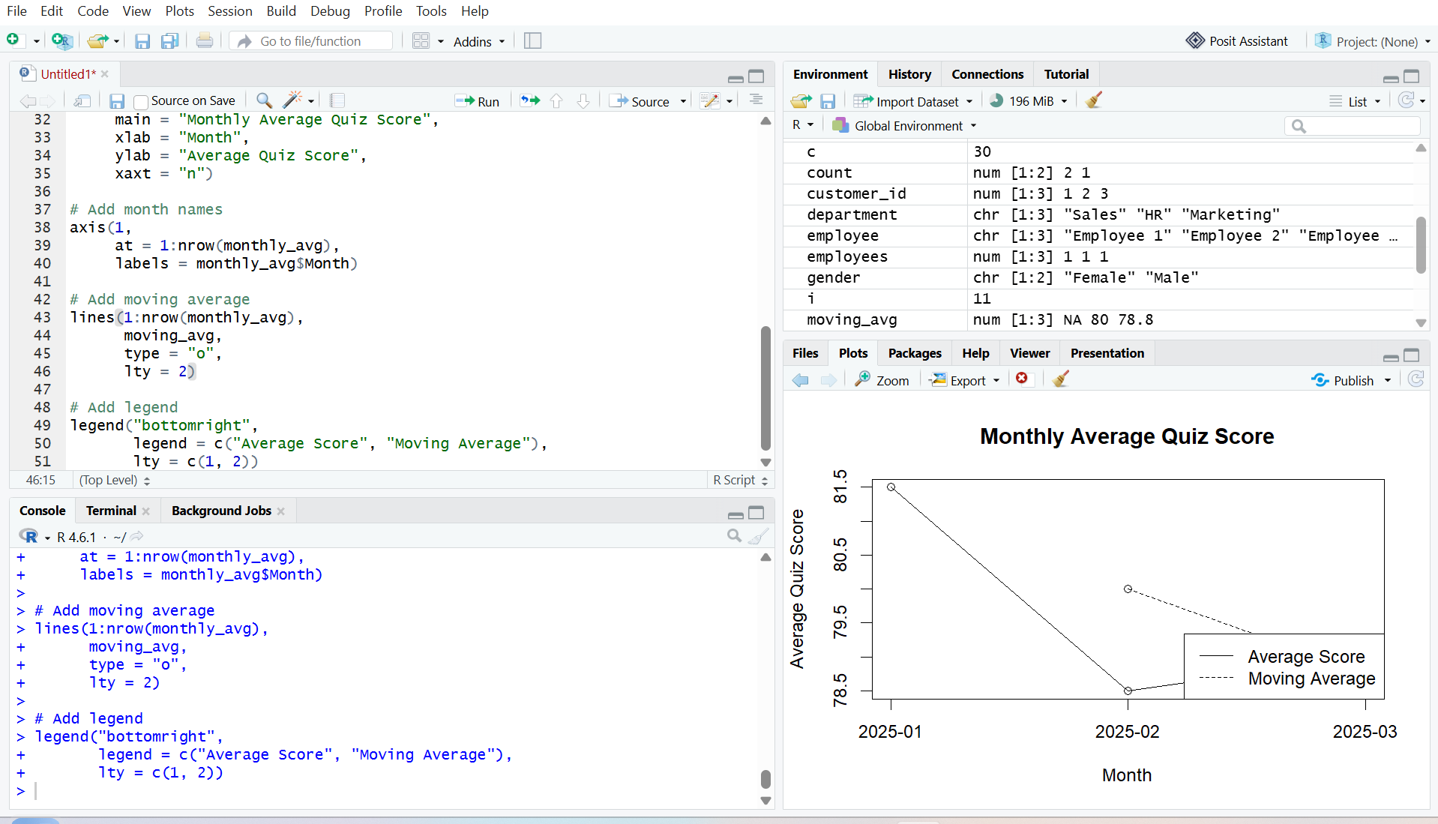
Output 3: Monthly Average Quiz Score with Moving Average
Observation
The line chart shows the monthly average quiz score. The moving average provides a smoother view of the overall student performance trend.

PROGRAM 4: Tableau Mini Interactive Dashboard
Import Online_Learning_Activity.csv into Tableau. Create a bar chart for average quiz score by course and a scatter plot for Study Time vs Quiz Score. Add Gender and Course filters.
Procedure:
- Import Online_Learning_Activity.csv into Tableau.
- Create a bar chart showing average Quiz Score by Course.
- Create a scatter plot using Study Time and Quiz Score.
- Use Videos Watched to represent the size of the bubbles.
- Add Gender and Course filters.
- Combine the charts into a mini dashboard.
- Add interactive filters.
- Save the Tableau dashboard.

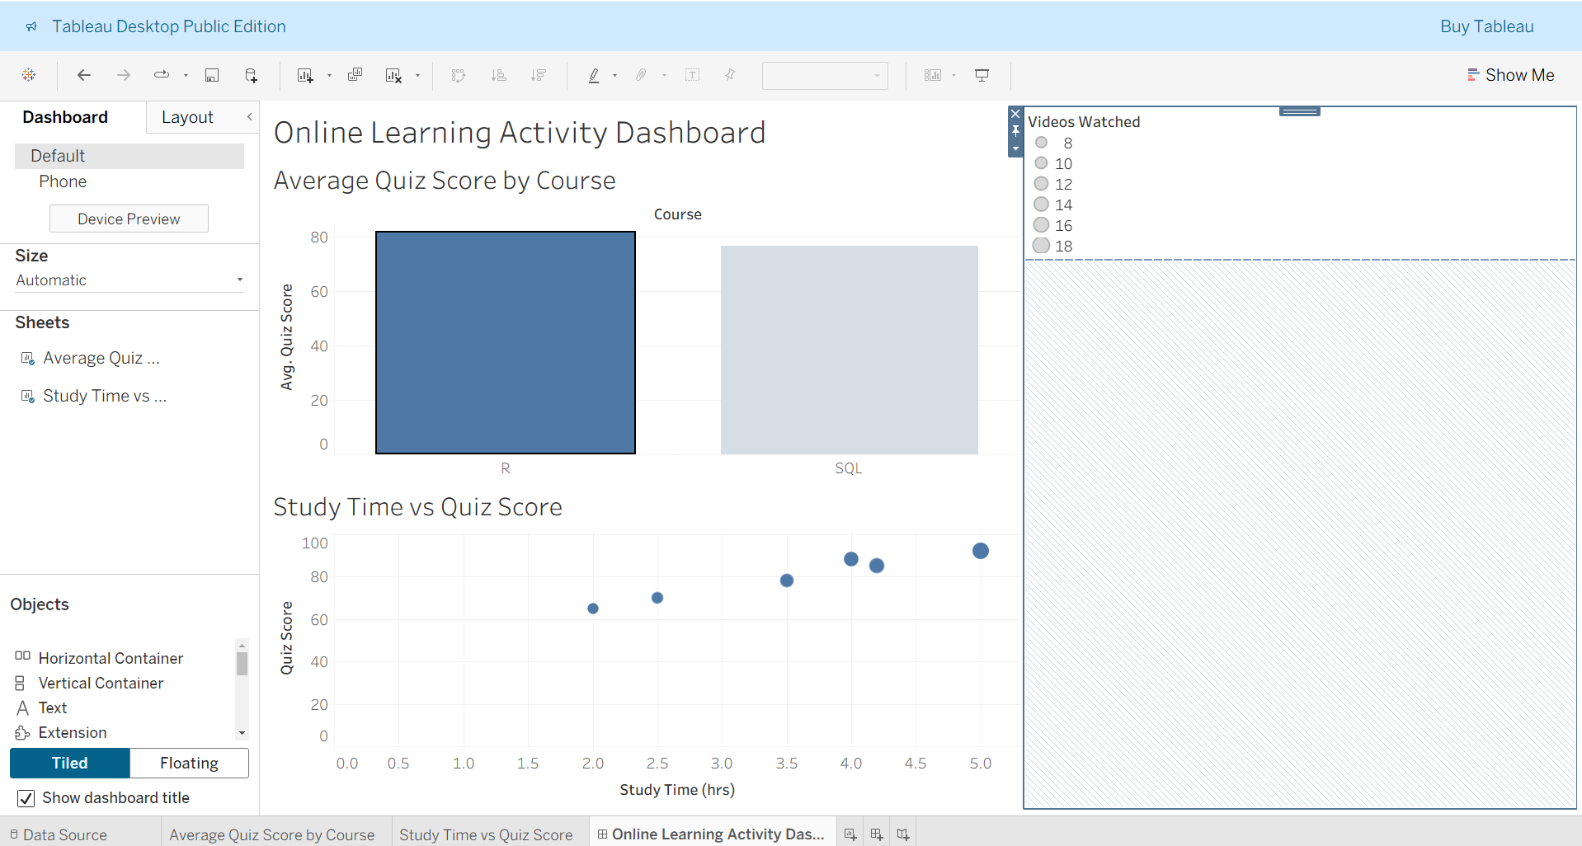
Output 4: Online Learning Activity Interactive Dashboard
Observation
The Tableau dashboard displays average quiz scores by course and the relationship between study time and quiz scores. Gender and Course filters allow interactive exploration of student learning activity.

Set 9 Procedure
- Import the Online Learning Activity dataset into R.
- Create a histogram and boxplot for Quiz Score.
- Create a bubble scatter plot between Study Time and Quiz Score.
- Convert Login Date into Date format.
- Calculate monthly average quiz scores.
- Create a line chart with moving average smoothing.
- Import the CSV dataset into Tableau.
- Create a bar chart for average quiz score by course.
- Create a scatter plot for Study Time vs Quiz Score.
- Add Gender and Course filters.
- Combine the visualizations into a mini interactive dashboard.
- Save the dashboard.
Set 9 Result
Online learning activity data was successfully analyzed using a histogram, boxplot, bubble scatter plot, and monthly line chart with moving average smoothing in R. A Tableau mini interactive dashboard was also created to analyze course-wise quiz performance and the relationship between study time and quiz scores.

